**Owner Agreement** 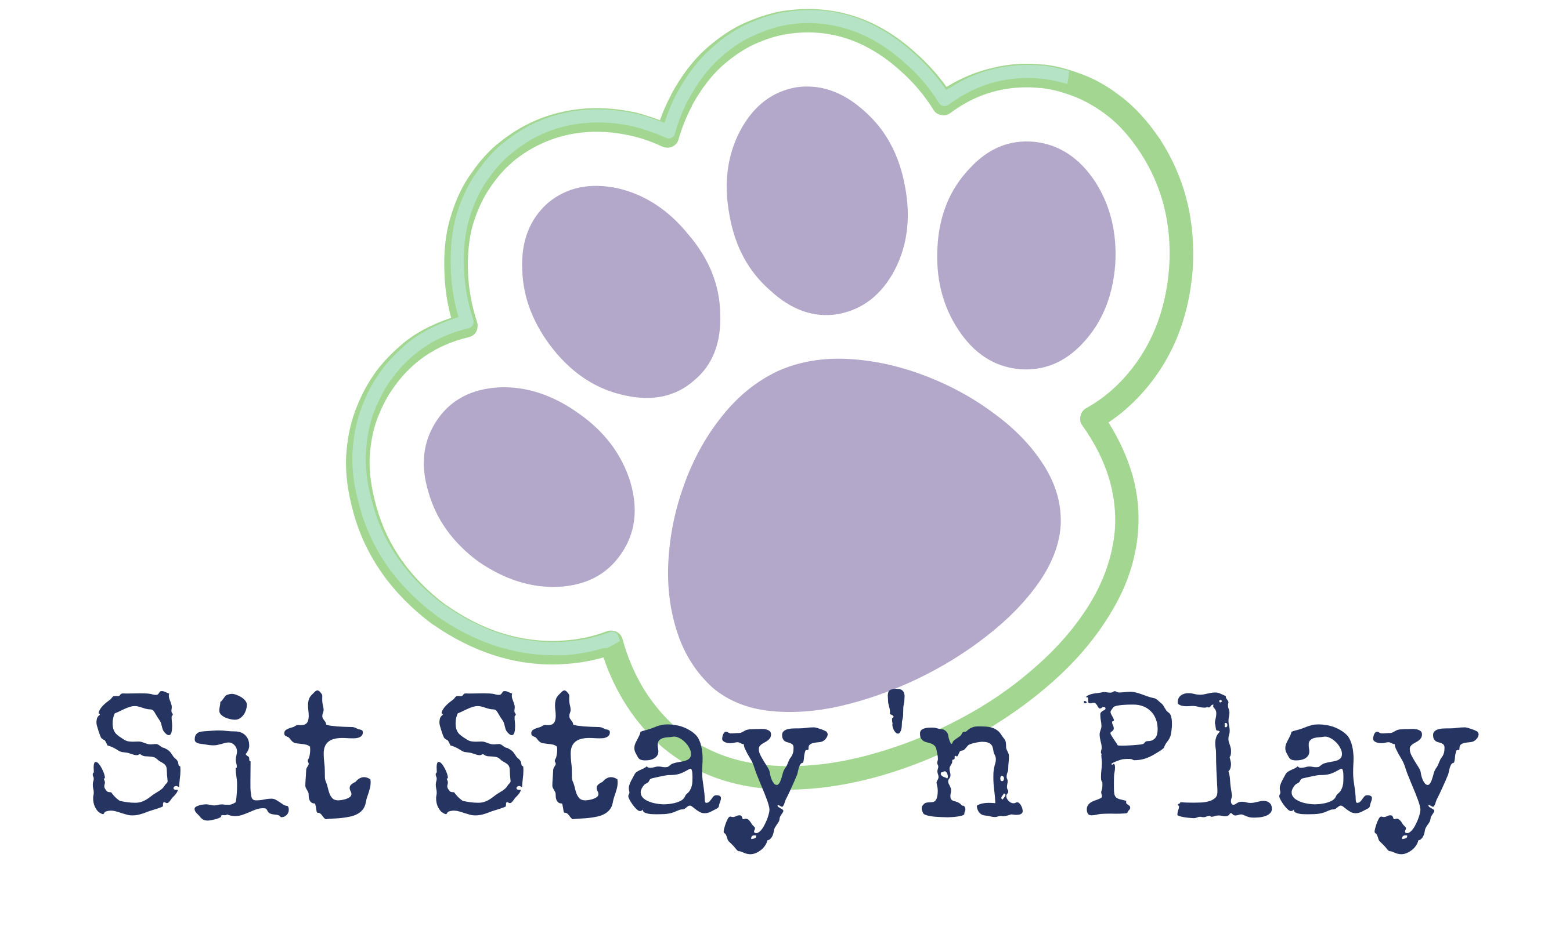

Please read, initial highlighted area, and sign. Thank you.

I agree to pay the rates that are in effect at the time my pet is at Sit, Stay, ‘n Play LLC. I agree to give at least 72-hour notice for boarding reservation cancellations. I acknowledge that Sit, Stay, ‘n Play LLC may charge a fee for all no shows, cancellations less than 72 hours’ notice, and all late pick-ups. When a reservation is made, we are holding that space just for your pet. We may have had to turn away others because our spaces were filled. If cancelling with less than 72 hours’ notice, we have denied another pet and have lost revenue for holding a space that could have been filled by another. Pre-payment is required after a no-show or cancellation with less than 72 hours’ notice. _______ (initial please)

I understand that on entering Sit, Stay, ‘n Play LLC, my pet(s) will be examined for fleas. If fleas are found, a flea bath and/or other flea treatment (Capstar) will be administered at my expense. ________

I understand that an interactive play setting is not without some risk of injury or illness, that despite all the dogs appearing healthy and being handled with the greatest amount of care and foresight, dogs are not always predictable and the unexpected may occur. I recognize that the benefits of an interactive playgroup are valuable to my dog and accept all the potential risks. I further agree to pay veterinary/medical expenses incurred as a result of injury or illness to or caused by my dog. I will not hold Sit, Stay, ’n Play liable for any injury or illness. _________

I agree to pay Sit, Stay, ‘n Play for any damages caused by a destructive pet. Furthermore, I agree that Sit, Stay, ‘n Play has permission to place a destructive pet in a large crate or kennel to prevent injury to my pet and to prevent further damages to property. Sit, Stay, ‘n Play reserves the right to refuse known destructive pets. Sit, Stay, ‘n Play LLC reserves the right to refuse services for any pet for any reason. ________

If my pet appears to be ill or injured, I authorize Sit, Stay, ‘n Play LLC to engage the services of a veterinarian at my expense, if Sit, Stay, ‘n Play deems it emergent and necessary for my pet's well-being, to seek veterinary care, to give other requisite attention, and to make whatever decisions are required for my pet's veterinary treatment. I agree to pay all veterinary charges incurred by my pet while in the care of Sit, Stay, ‘n Play LLC. I will not hold Sit, Stay, ‘n Play LLC liable for failure to seek veterinary attention or for decisions made under this contract. This signed agreement serves as a “Release to Treat” for veterinary services. I understand that Sit, Stay, ‘n Play will make every possible attempt to notify me prior to seeking and obtaining emergency care. I, however, agree that Sit, Stay, ‘n Play has the authority to use their best judgement and to act in my pets’ best interest even if this means seeking treatment before I am notified. Emergency care will first be sought at my own vet but in some cases my vet may not be available. This agreement releases the on-call vet, after-hours clinic, or MSU to treat in case of emergency situations. Should my pet become ill or injured, this is the maximum dollar amount I authorize: $___________ ________

I understand that Sit, Stay, ‘n Play LLC will exercise all due diligence and care in the guardianship of my pet. I hereby waive and release Sit, Stay, ‘n Play LLC, its employees, owners, and agents from any and all liability of any nature, for injury, illness, or damage, including that which may result from the action of any dog including my own, and I expressly assume the risk of such damage or injury/illness while my dog participates in or attends any function of, or boarding at Sit, Stay, ‘n Play LLC, while on the grounds or the surrounding area thereto. Sit, Stay, n Play will not be held liable for any injury or illness unless injury or illness is caused by negligence. ________

Sit, Stay, ‘n Play LLC reserves the right to refuse services for any pet for any reason.

I warrant that I have the authority to represent all owners of this pet in signing under the contract. On behalf of myself and all owners of this pet, I certify that I have read and understand the policies of Sit, Stay, ‘n Play LCC as set forth in the above agreement, and accompanying forms and releases, and that I have read and understand the conditions and statements of this agreement.

Owner Name (print) ______________________________Signature________________________________________

Name(s) of Dog(s) _______________________________________________________________________________

Date ___________________